***PricePerch : Revolutionizing House Price Prediction***

* + ***BHAVYA KAPADIA (IIIT –*** ***BANGALORE)***
* OBJECTIVE:
* PricePerch is a project designed to develop a robust house price prediction model for Bengaluru using Machine Learning, Data Science and Web Development. By analyzing genuine factors like location, amenities, and market trends, the model aims to provide accurate and data-driven house price predictions, countering the often-exaggerated prices in the market. The project involves collecting and preprocessing data, developing, and validating Machine Learning models, and integrating these models into a user-friendly web interface. The goal is to offer a reliable tool for buyers, sellers, and investors, ensuring transparent and fair pricing in Bangalore's dynamic real estate market.
* GITHUB REPOSITORY:
* <https://github.com/BKAPADIA04/PricePerch>
* DEMYSTIFYING PRICE-PERCH: A Step-by-Step Guide to Building a Home Price Prediction Model:
* Our journey to understand Bengaluru home prices unfolds in a series of steps. First, we will **load the dataset** and delve into **exploratory data analysis** to understand its structure and relationships between features. Next comes **data cleaning**, where we will tackle missing values and inconsistencies. To enhance the model's focus, we might engage in **feature engineering** by creating new informative features from existing ones. If the data has high dimensionality, we might explore **dimensionality reduction** techniques to make it more manageable. Outliers can skew results, so we will employ both **business logic** and statistical methods like **standard deviation and** **mean** to identify and potentially remove them. Throughout this process, **data visualization** will be our ally, helping us interpret patterns and identify areas for improvement.
* Before building a model, we will also perform a **multicollinearity check**. This ensures that our features are not too highly correlated with each other. High correlation can make it difficult to interpret the model's coefficients and can lead to inaccurate predictions.
* Once the data is squeaky clean and informative, we will embark on **building a model** to predict home prices. To assess its performance, we will **test the model** on a few properties and finally **export the trained model** to a joblib file for future use. This comprehensive approach will equip us to understand and predict the ever-evolving Bengaluru housing market.
* DATA COLLECTION:
* DATASET: <https://www.kaggle.com/amitabhajoy/bengaluru-house-price-data>
* This dataset on Bengaluru home prices comes from Kaggle. It contains a wealth of information about properties, including factors that can influence their value. These factors include details like the type of area (apartment, villa, etc.), whether it is available for purchase or rent, the specific location within Bengaluru, the number of bedrooms, halls, and kitchens (BHK), the society or complex name (if applicable), the total square footage, and the number of bathrooms and balconies.
* DATA CLEANING:
* To streamline our analysis and focus on key factors influencing price, we removed four columns from the initial dataset. The "area_type" column, with only four categories, offered limited value. "Availability" reflects a property's status at a specific time, making it less relevant for broader price trends. The "society" column, unfortunately, contained a high number of missing values, hindering its usefulness. Therefore, we will concentrate on user-provided information like location, number of bedrooms (BHK), and the number of bathrooms to create a more targeted analysis.
* FEATURE SELECTION & OUTLIER DETECTION:
* For 2BHK and 3BHK homes, ensure each BHK has at least 300 sqft (about the area of a parking space), making the total minimum area 600 sqft (about twice the area of a parking space) for 2BHK and 900 sqft for 3BHK. The number of bathrooms should not exceed BHK + 1. Filter out any configurations other than 2BHK and 3BHK. Rigorously identify and remove statistical outliers in the price_per_sqft column, assuming it follows a normal distribution. Additionally, eliminate higher BHK homes that are priced lower than comparable lower BHK homes in the same location to maintain market consistency.
* Outlier Detection for Maintaining Market Consistency by Eliminating Higher BHK Homes Priced Lower Than Comparable Lower BHK Homes:
* Before Outlier Detection Logic

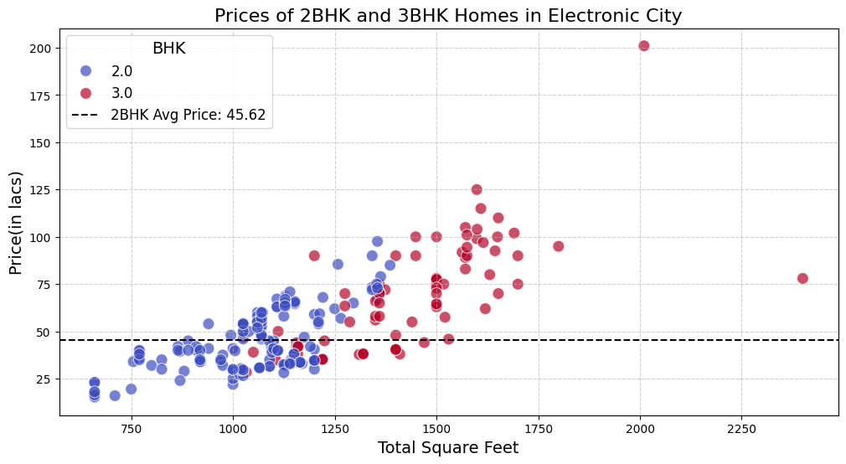

* After Outlier Detection Logic

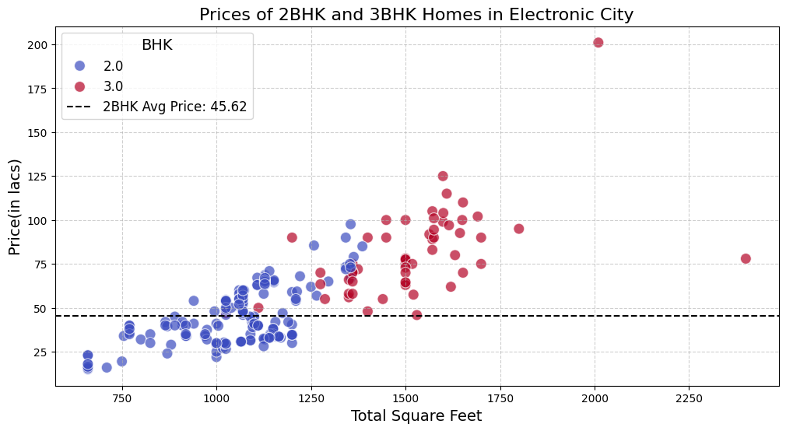

* MODEL:
* To build our predictive model, we began by implementing One Hot Encoding on the categorical variable representing locations. This preprocessing step enabled us to apply linear regression techniques effectively. We employed several regression methods, including standard Linear Regression and regularization techniques such as Ridge Regression (L2), Lasso Regression (L1), and Elastic Net Regression, to address potential multicollinearity and overfitting issues. The performance of these models, measured by the R² score, ranged consistently from 0.853 to 0.854 across all the regression methods, demonstrating their robustness and minimal variance. Given the comparable performance, we selected Scikit-Learn's Linear Regression for its simplicity and efficiency. Finally, to facilitate future use and deployment, we saved our trained model using both pickle and joblib libraries, ensuring reliable and efficient serialization.
* TECH STACK:
* Our tech stack comprises a robust combination of modern frameworks and tools. For the frontend, we utilized React JS, known for its efficiency and flexibility in building dynamic user interfaces. The server side is powered by Node.js, alongside the Express.js backend framework, which provides a fast and scalable environment for handling server operations. The machine learning model's API was developed using Flask, a lightweight WSGI web application framework in Python, which facilitated seamless integration and communication between the model and the Node.js server. This integration ensures a smooth and responsive interaction between the frontend and backend, delivering an optimal user experience.
* Showcasing The Glimpses:

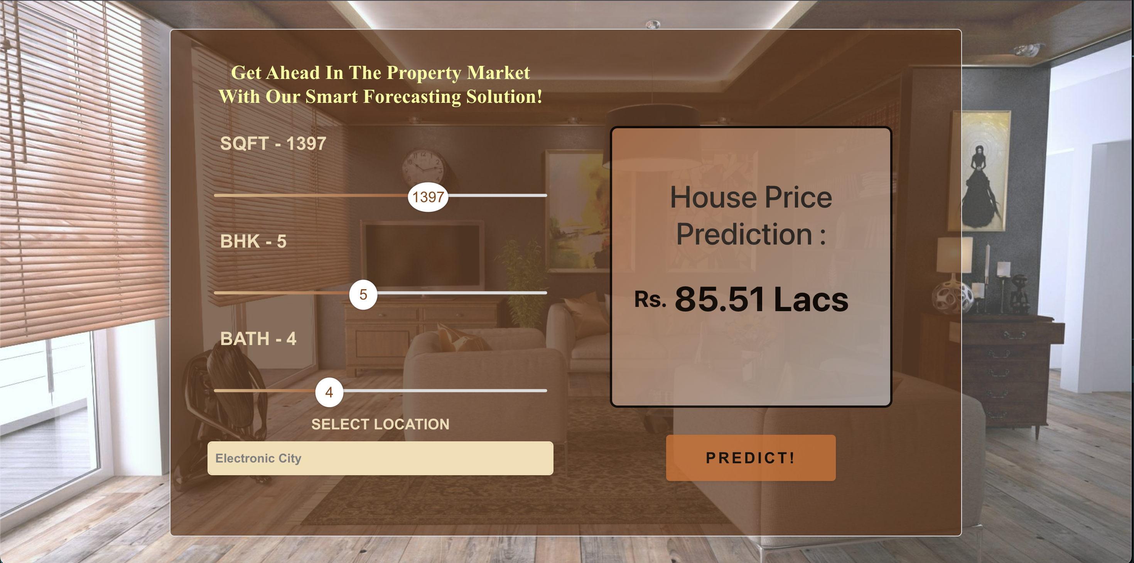

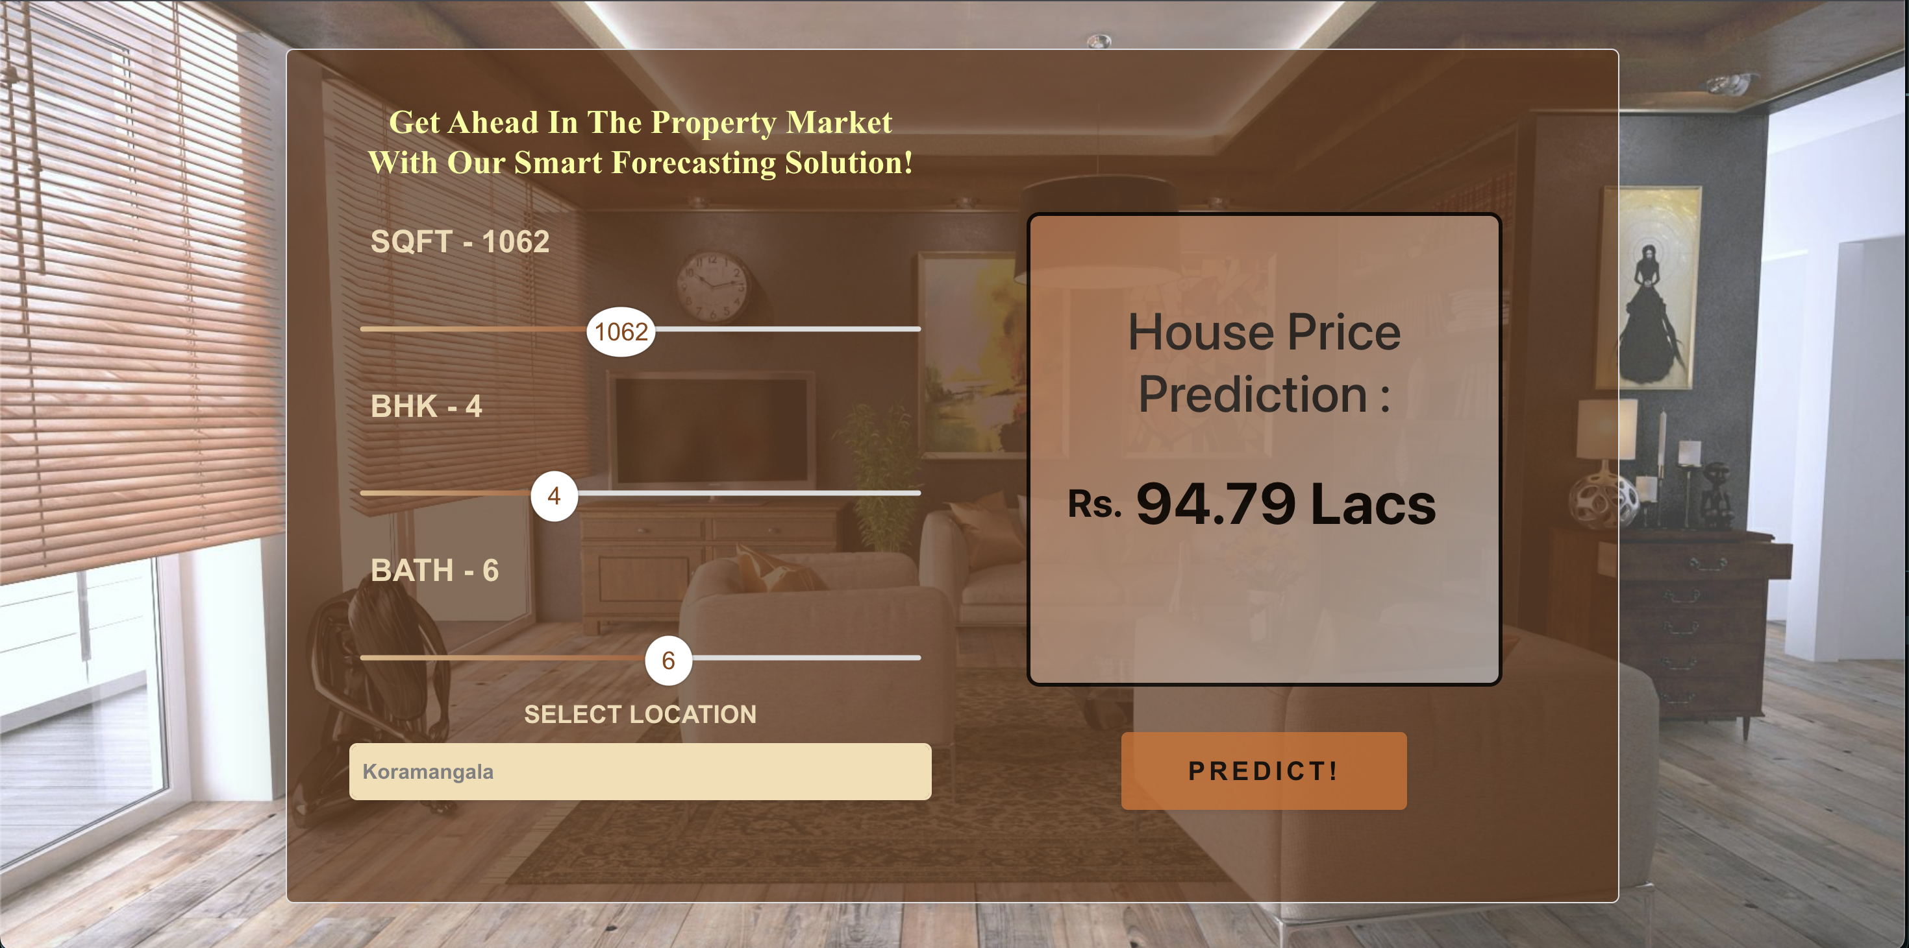

------------------------------------------x------------------------------------------